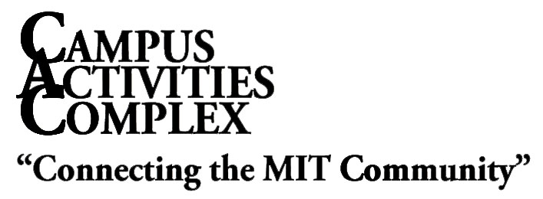
W20-500
Phone: 617-253-3913
Email: cacscheduling@mit.edu
Web: studentlife.mit.edu/cac

Department Space Application

This form is to be completed by a faculty/staff member of an MIT department, program, or non-student group in order to reserve facilities in the Campus Activities Complex. Forms must be submitted at least one week in advance to the CAC office, W20-500. Please note that this form is an application. Submitting a completed form does not ensure that the space has been reserved for you. Please do not consider your application approved until receiving written confirmation from the CAC office.

Department/Group: *Cost Center:

Requestor: G/L Account:

MIT Address: Phone:

Status at MIT: Email:

*Required of all reservations regardless of whether fees will apply. The space requestor must also be authorized to commit funds on the designated cost center.

Event Title:

Event Type: |  | Meeting |  | Lecture |  |  | Party |  |  |  |  | Conference
 |  | Rehearsal |  | Performance | Other:
Date(s) | Location(s) | Event Start  AM/PM | Event End  AM/PM | Setup  Ready By

How many people do you anticipate attending the event?

Consult diagrams in the CAC Office or the “Event Planning Guide” at mit.edu/eventguide/ before selecting a setup style. Equipment will be based on estimated attendance. Please realize that some rooms have fixed setups.

Setup Style: |  | Conference |  | Lecture |  |  | U-Shape |  |  |  | Hollow Square |  |  |  |  | Banquet
 |  | Classroom |  | To be arranged with a CAC Manager
 |  | No Set-Up |  | Additional Equipment

 | YES | NO
Will an admission/registration fee be charged?
Are you sponsoring a non-MIT group?
Name of the non-MIT group?
Will this event be open to the general public?
How will this event be promoted?
Will alcohol be served?
Will there be minors? (non-MIT under 18)
Will there be music?
Will there be a DJ/Live Band?
Is there a contract involved?
Do you intend to sell anything?

Will you have Audio Visual needs?
Audio Visual Provider?
*Do you plan to have food at the event?
Who will be your caterer?

If you do not use an MIT caterer, you may need to provide the CAC with a copy of your caterer’s liability insurance prior to the event. This only applies if food is being served by wait staff.

Will the intended audience of your event be: (check one)

Immediate MIT Community Only non-MIT and MIT Community

On behalf of the above MIT Department/group, I agree to adhere to all conditions outlined above, all Institute policies and procedures, and laws of the Commonwealth of Massachusetts.

Signature |  |  | Date

FOR OFFICE USE ONLY

Approved___________________ | Denied _______________ | Scheduler’s Initials ________
Pricing Code ________________ | Determined by _____________ | Date ___________

Revised: November 2022

