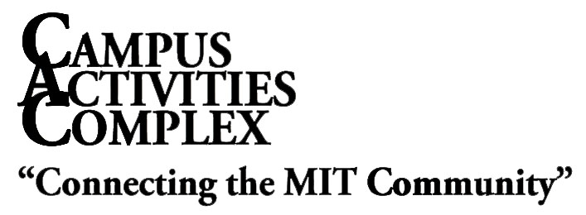
W20-500
Phone: 617-253-3913
Fax: 617-253-8585
Email: campus-activities@mit.edu
Web: studentlife.mit.edu/cac

Student Activity Space Application

This form is to be completed by an authorized member of an ASA recognized student group, residence hall, Sloan student group, or FSILG group in order to reserve facilities in the Campus Activities Complex. Forms must be submitted in person at least one week in advance to the CAC office, W20-500. Please note that this form is an application. Submitting a completed form does not ensure that the space has been reserved for you. Please do not consider your application approved until receiving written confirmation from the CAC office.
YES NO
Student Group: ASA Recognition?

Name of Phone:

Reservation Signatory: Email:

Are you one of the student activity members authorized to reserve rooms on the ASA Reservation Signatory list? If not, contact the president, or treasurer of your group.

Event Title:

Event Type: |  | Meeting |  | Lecture |  |  | Party |  |  |  |  | Conference
 |  | Rehearsal |  | Performance | Other:
Date(s) | Location(s) | Event Start  AM/PM | Event End  AM/PM | Setup  Ready By

How many people do you anticipate attending the event?

Consult diagrams in the CAC Office or the “Event Planning Guide” at Web: mit.edu/eventguide/ before selecting a setup style. Equipment will be based on estimated attendance. Please realize that some rooms have fixed setups.

Setup Style: |  | Conference |  | Lecture |  |  | U-Shape |  |  |  | Hollow Square |  |  |  |  | Banquet
 |  | Classroom |  | To be arranged with a CAC Manager
 |  | No Set-Up |  | Additional Equipment

 | YES | NO
Will an admission/registration fee be charged?
Are you sponsoring a non-MIT group?
Name of the non-MIT group?
Will this event be open to the general public?
How will this event be promoted?
Will alcohol be served?
Will there be minors? (non-MIT under 18)
Will there be music?
Will there be a DJ/Live Band?
Is there a contract involved?
Do you intend to sell anything?

Will you have Audio Visual needs?
Audio Visual Provider?
*Do you plan to have food at the event?
Who will be your caterer?

If you do not use an MIT caterer, you may need to provide the CAC with a copy of your caterer’s liability insurance prior to the event. This only applies if food is being served by wait staff.

Will the intended audience of your event be: (check one)

Immediate MIT Community Only non-MIT and MIT Community
(Must possess valid MIT I.D. card, i.e. – Alumni)
On behalf of the above Student Activity, I agree to adhere to all conditions outlined above, all Institute policies and procedures, and laws of the Commonwealth of Massachusetts.

Signature |  |  | Date
MIT ID #

FOR OFFICE USE ONLY
ASA Recognized? Y N Approved Denied
Authorization List on File? Y N
Requestor authorized to reserve rooms? Y N Scheduler’s Initials

If no, approved by SAO / FSILG / RLP ____________________ Date________

Verified by _____________________

Revised: July 2014

